Chapter 4, Problem 71.

For the circuit in Fig. 4.137, what resistor connected across terminals a-b will absorb maximum power from the circuit? What is that power?

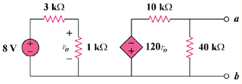

Figure 4.137
For Prob. 4.71.

